Synthesis and Cancer Treatment Effects of
O-(4-bromo)-phenyl-N-(9’-acridinyl)-hydroxylamine
Nevin Gilbert
University of Northern Colorado
Frontiers of Science
Research Sponsored by Xcel Energy

Abstract
Cancer is a major concern all around the world being one of the hardest to cure and affecting the most people. This fact has necessitated further anti-cancer drug research and as a result the 9 aminoacridine has been evaluated for its anti-cancer tumor properties. The 9-aminoacridine compound is known as a DNA intercalates since inserts itself between base pairs of DNA to interrupt vital biological function therefore inducing apoptosis. Although it is possible that this compound could kill healthy cells, it will more likely attack cells with rapid proliferation, specifically cancer cells. Current drugs require high dosages since they do not bind well to the DNA, therefore this research hopes to initiate an exploration of the effect of different substituent groups on anti-cancer drugs. The goal of this project is to synthesize a bromine substituted derivative of O-phenyl-N-(9’-acridinyl)-hydroxylamine, a novel 9 aminoacridine. Since bromine is deactivating it will make the intercalating portion slightly positive, binding to the negative DNA tighter.
Table of Contents
Abstract 1
Introduction 3
Review of Literature 5
Methods and Materials 12
Overview 12
Synthesis of Diaryliodonium Triflate Salt 14
Synthesis of N-phenyloxyphthalimide 14
Hydrolysis of N-phenyloxyphthalimide 15
Synthesis of O-(4-bromo)-phenyl-N-(9’-acridinyl)-hydroxylamines. 16
Results and Discussion 18
References 24

Introduction
Cancer is among the leading health concerns in the world today and is caused by abnormal, mutated cells which are able to divide faster than normal cells. These cells then begin to bundle together forming tumors. The tumors can either be benign or malignant tumors, the malignant ones being cancer cells. These cells go through a process known as metastasizing where they are able to expand to the rest of the body (National Cancer Institute). Although the cancer mortality rate has decreased by 13% since 2012, there is no doubt that more effective treatments with lesser side effects are needed. Cancer cells are able to evade the normal cell death process known as apoptosis. “The most common method is the loss of the apoptosis gatekeeper, the protein P53. More than half of all types of human cancers have a mutated or missing gene for P53, resulting in a damaged or missing P53 protein. (Samarasinghe, 2013)” Cancer treatments such as chemotherapy induce apoptosis in rapidly proliferating populations which includes tumors but also other cells such as hair cells (Kerr, 1994). If more effective drugs can be given to patients, then there is a possibility of reducing the side effects that existing treatments carry.
9- Aminoacridine derivatives, also known as DNA intercalates, have been thoroughly studied and are known to lead to cell cycle arrest and induce apoptosis (Kumar, 2013). Unfortunately, the problem with these intercalation cancer treatment drugs is that they suffer from hydrolysis requiring higher dosages of the drug. DeSelm performs scholarly research on a 9–aminoacridine derivative known as O-phenyl-N-(9’-acridinyl)-hydroxylamine and analyzes its cancer treatment properties. The purpose of this paper is to expand upon that research by synthesizing a different derivative and by exploring the effects that a derivative of O-phenyl-N-(9’-acridinyl)-hydroxylamine has on its ability to bind to human DNA, therefore improving their effectiveness and reducing dosages required. Hopefully this research will be able to determine the efficacy of the 9–aminoacridine and its derivatives in treating cancer and discover how different derivatives affect the longevity of the drug.

Review of Literature
The main idea behind creating this drug is to induce apoptosis in rapidly producing populations which will ideally primarily target cancer cells. Apoptosis is a mode during cell’s lifecycles which is responsible for killing off unnecessary cells in the body. When apoptosis takes place there is a cleavage of double stranded DNA at the joint where the two strands twist: if the cell has a break in DNA unexpectedly it leads to cell cycle arrest, unless the break is repaired. Cells have mechanisms to do this in many cases, however this drug, should prevent the break from being repaired, leading to apoptosis.
Apoptosis covers two unique cell functions (Kerr, 1994). It serves to complete an entirely regular task in normal tissue of deleting unneeded cells; however it is also induced by CTL cells when it is believed that a cells survival will be harmful to the remainder of the body. It is when this does not function as expected that we see cancer cells persist. Existing chemotherapy treatments induce apoptosis in cell population experiencing quick proliferation which is effective in attacking tumor tissue, but other rapid proliferation tissues such as hair are also affected which is the reason for the side effects patients experience.
Many articles can be found on the 9–aminoacridine compound also known as a DNA intercalates. Acridines were first developed as dyes and during the early 20th century, its pharmacological properties were evaluated. The compound was further evaluated beyond a dye as more anti-cancer treatment drugs were necessitated. The drug has been labeled as an anti-inflammatory, anti-malarial, antimicrobial, and anticancer agent. “The great majority of antitumor agents in the present clinical use are thought to exert their cytotoxic action by interfering with DNA metabolism, some binding non-covalently and reversibly to DNA and exerting their action either by inhibition of nucleic acid synthesis or by inhibition of DNA breakage and repair phenomenon (Kumar, 1994).” O-phenyl-N-(9’-acridinyl)-hydroxylamines, whose synthesis was attempted in a paper by DeSelm, functions by binding to the DNA. Some derivatives were synthesized in a research project by Kumar and it was concluded that the derivatives possessed anti-cancer properties against lung cancer and cervical cancer. In this article it was suggested that more derivatives of 9 – aminoacridines are synthesized to further explore more anti-cancer properties.
How DNA intercalates impact cell proliferation is not fully understood and as a result Danko explored the topic further. During intercalation the cell DNA is unwinded and there is a space opened between the base pairs of the strand. “The changes in the DNA structure disturb biological functions, such as transcription, replication and the DNA repair process. For that reason, inserting ligands, or intercalators, can be used as antitumor drugs and antiseptics (Valentino, 2009).” According to the paper by Valentino an existing intercalator known as Ellipticine is a natural plant product which exhibits powerful antitumor and anti-HIV activities.
Hydrolysis is a common problem among the existing derivatives of cancer treatment drugs. The reality is that 9 aminoacridines are the most valuable of the acridines due to their anti-tumor potential; however their sustainability in vivo is yet to be explored thoroughly. Looking at the research done by Goodell, we can see that the 9-aminoacrdine often hydrolyzes at the C9 -N15 bond shown below.
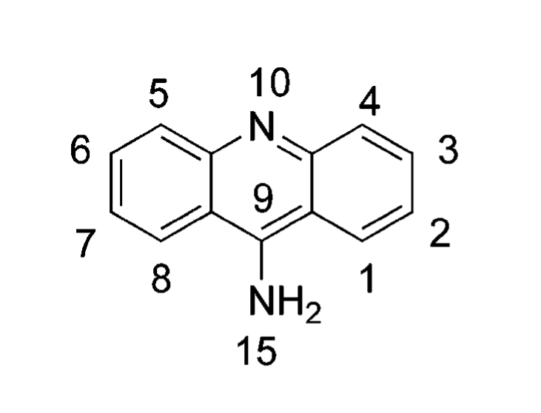
Figure 1. Location of the C9-N15 bond, the most common location of hydrolysis in 9-aminoacrdine

The research investigates the rates of hydrolysis going from primary to secondary and to tertiary substituted 9-aminoacridines. In the case of tertiary substituted amines, the calculations indicate the C9 - N15 bond is forced into a “more gauche-like conformation, greatly diminishing delocalization, which leads to rapid hydrolysis”. The present research hopes to find out the effects of bromine substituents on the hydrolysis of a cancer treatment drug (Goodell, 2006).”
Topoisomerase is an enzyme in cells which is vital to DNA unwinding and replication. DNA topoisomerase I and II are both regarded as strong anti-cancer agents in research today. Topoisomerase I function by cutting one strand of the DNA and unwinding it around the other. On the other hand, topoisomerase II cuts both strands of the DNA and unwinds them around each other. In addition type II also goes back and repairs the break. By inhibiting the topoisomerase then, we are able to develop anti-tumor drugs; these drugs either behave as a catalytic inhibitor or as a poison. “In general, topoisomerase inhibitors are divided into two main categories: poisons and catalytic inhibitors. Poisons, which include the most widely used drugs clinically for treating cancers, function by binding to the covalent DNA-topoisomerase enzyme and preventing DNA relegation after DNA strand cleavage occurs (Gálvez-Peralta, 2009).” On the other hand, when functioning as a catalytic inhibitor rather than poison, the topoisomerase induce a G1-S phase arrest followed by apoptotic cell death. In the research done by Gálvez-Peralta it shown that a new cancer agents using topoisomerase II catalytic inhibitor were found to significantly reduce the proliferation of tumor tissue cells injected into mice.
Synthesis of the drug is explained by a combination of the work done by DeSelm and the work done by Ghosh in creating various derivatives of diaryliodonium triflate salts. In the research done by DeSelm a method for the synthesis of O-phenyl-N-(9’-acridinyl)-hydroxylamines was outlined as follows:

Step 1: Synthesis of Diaryliodonium Triflate
Figure 2 Synthesis of Diaryliodonium Triflate

Step 2: Synthesis of N-phenyloxyphthalimide
Figure 3. Synthesis of N-phenyloxyphthalimide

Step 3: Hydrolysis of N-phenyloxyphthalimide

Figure 4. Hydrolysis of N-phenyloxyphthalimide (Method III)

Step 4: Synthesis of O-phenyl-N-(9’-acridinyl)-hydroxylamine
Figure 5. Synthesis of O-phenyl-N-(9’-acridinyl)-hydroxylamine

In the first two steps the synthesis of N-aryloxyimides and aryloxamines take place. In Ghosh’s article, Metal-Free Synthesis of N-Aryloxyimides and Aryloxyamines, The procedure to create the N-phenyloxyphthalimide has been explained. In addition to these methods, Ghosh shows how to add different substituents such as a nitrate or bromine group to the diaryliodonium triflate salt. The procedure done by DeSelm uses iodobenzene and benzene, however following Ghosh’s article; we will use the compounds outlined, 1 bromo-(4-iodo)-benzene and bromobenzene, in order to figure out how it will affect the efficacy of the end product.
In DeSelm’s research the product created in step 3 is available for purchase, however adding substituent groups at this point in the drugs synthesis proves to be much more difficult than adding them in the initial stage as outlined by Ghosh. In addition the product from step 3 is very costly and being able to synthesize it would be beneficial.
The bromine group which this research hopes to attach to the benzene rings in the reaction should end up making the product attach to the DNA stronger. Whether or not this is what is desired in cancer treatment drug is unsure since the drug will kill all rapidly proliferating cells in the same way. A drug that bonds better to the DNA could potentially healthy cells creating different undesired effects. The bromine group added derivative will bond to the DNA stronger since the group is deactivating as shown below. This means that it takes away electrons which will make the compound more positively charged, and since DNA has a slight negative charge, it will attach itself better to the DNA. 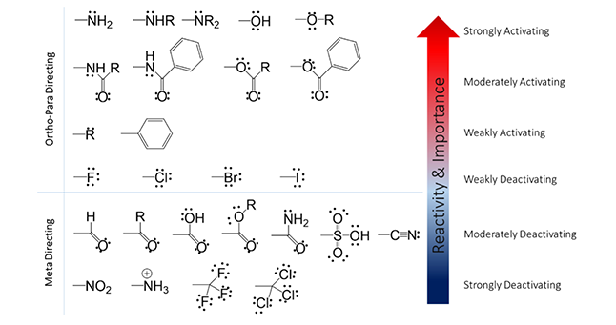
Figure 6. Bromine is a weakly deactivating substituent.
The final product and the compounds created during the procedure, according to work done by DeSelm, Ghosh, and Danko, can be identified using many different techniques such as TGGE, H-NMR, and an IR.

Methods and Materials

Overview
The synthesis of the novel antitumor drug, O-(4-bromo)-phenyl-N-(9’-acridinyl)-hydroxylamines, is a four step procedure outlined by Ghosh, DeSelm, Bielawski, DeSelm, and Carlson. The first step in creating the product is the synthesis of a diarylodonium triflate using 1 bromo-(4-iodo)-benzene and bromobenzene. The second step is then performed immediately after due to the instability of the product. The second step is the synthesis of N-phenyloxyphthalimide. This is done by reacting the trifalte salt from the previous steps with N-hydroxyphthalmide. At this point, the product is analyzed using a variety of methods to ensure that the expected compounds have been produced before proceeding to step 3. Step 3 is the hydrolysis of N-phenyloxyphthalimide which can be done a few different ways. In this research the N-phenyloxyphthalimide will undergo hydrolysis mainly through the use of hydrochloric acid. In the final step O-(4-bromo)-phenyl-N-(9’-acridinyl)-hydroxylamines, the goal of the research, is synthesized through a reaction with 9-choloracridine.
Step 1: Synthesis of Diaryliodonium Triflate
Figure 7. Synthesis of Diaryliodonium Triflate

Step 2: Synthesis of N-(4-bromo)-phenyloxyphthalimide
Figure 8. Synthesis of N-phenyloxyphthalimide

Step 3: Hydrolysis of N-(4-bromo)-phenyloxyphthalimide

Figure 9. Hydrolysis of N-phenyloxyphthalimide (Method III)

Step 4: Synthesis of O-(4-bromo)-phenyl-N-(9’-acridinyl)-hydroxylamines
Figure 10. Synthesis of O-phenyl-N-(9’-acridinyl)-hydroxylamine

Synthesis of Diaryliodonium Triflate Salt
By using the procedures described by Bielawski, the triflate salt is able to be synthesized. A clean round bottom flask is stoppered and kept under inert atmosphere conditions by introducing argon gas. At this point 2mL of dichloromethane (DCM) were added to the flask followed by 116 mg (0.52 mmol, 1.1 equivalents) of mCPBA. After adding these, 54.43μL (0.52 mmol) of bromobenzene is added preceding 120μL (3.0 equivalency) of trifluoromethanesulfonic acid. Finally 130.13mg of 1-bromo-(4-iodo)-benzene is added to the mixture and it is stirred for 1 hour at room temperature. After 1 hour the solution is put in a rotary evaporator at 25 degrees Celsius to remove the solvent. To the mixture is then added 2mL of dietholether (Et₂O) which is then stirred for 10 minutes. This process will force the impurities in the solution into the dietholether and the product to crystalize. The flask is left in the fridge for at atleast 30 minutes before removal. The solid was then washed with Et₂O and rotary evaporated again to dry the diaryliodonium salt crystals before proceeding with the next step.

Synthesis of N-phenyloxyphthalimide
The methods to synthesize the N-phenyloxyphthalimide are outlined by Ghosh and are used in these procedures. In a new 25mL round bottom flask, 61.7mg of Potassium t-butoxide (t-BuOK) was dissolved in 2mL of anhydrous dimethyl formamide (DMF). Then 61.7mg of N-hydroxyphthalimide was added to the flask and the mixture was stirred for 10 minutes. If the compounds do not dissolve 2 more mL of DMF are added to the mixture before the triflate salts from the previous step are added. After adding the triflate salts, the flask is brought to 60 degrees Celsius using a variac and mantle and the mixture is stirred for 1 hour. After stirring was completed, the compound and solvent along with 20mL of deionized water and 20mL of ethelacetate are added to a seperatory funnel. The solution is shaken vigorously in order to mix the solution thoroughly and then the aqueous layer is drained into a waste beaker. 20 more mL of deionized water area added and the process is repeated three times. On the fourth time, rather than adding DI water, 20mL of brine was added, turning the solution a milky white color, to ensure the best separation of the organic and aqueous layer. The organic layer was then transferred to a 50mL Erlenmeyer flask which was stoppered. At this point added is anhydrous sodium sulfate in small increments. After each increment the flask is shaken vigorously to help absorb any remaining water in the solution. The increments were stopped when the anhydrous sodium sulfate stopped clumping together and started to look like a snow globe in the Erlenmeyer flask. Using gravity filtration, the solid was removed from the mixture and the remaining compounds were drained into a new 25mL round bottom flask. The flask was left under a fume hood allowing the ethelacetate to evaporate, leaving behind N-phenyloxyphthalimide.

Hydrolysis of N-phenyloxyphthalimide
Although there are many ways to send the N-phenyloxyphthalimide through hydrolysis, in this research the method outlined by Carlson where the compound was under acidic conditions was used. The compound in a 25mL round bottom from the previous step will be transferred to a 100mL round bottom flask to begin. The flask will be heated to 50 degrees Celsius using a variac and a heating mantle following which 15 mL of glacial acetic acid and 5 mL 37% hydrochloric acid (HCl) will be added. The solution will be heated to reflux, where the vapors turn to stock. At this point 1 mL of 37% HCl will be added to the round bottom flask periodically for 2 hours as it refluxes. After two hours the round bottom will be set out to cool to room temp. At this point the flask will be rotovapped to remove all acid and the remaining solid was scraped and transferred to a 50mL Erlenmeyer flask. To ensure the highest yields, the 100mL round bottom will be rinsed with DI water and added to the Erlenmeyer flask; the resulting solution should be no greater than 20mL. At this point in the hydrolysis the solution will be made alkaline by through the dropwise addition of 10% sodium hydroxide (NaOH). The new mixture will be transferred to a 125mL seperatory funnel along with 30mL of DCM and the aqueous layer was removed three times. After using the seperatory funnel, the compounds were dried by using anhydrous sodium sulfate after which gravity filtration was used to remove the solid. HCl was bubbled through the solution to ensure that no more precipitate is formed, and then let to stir for 30 minutes After being filtered using suction filtration, the solid is let to dry overnight.

Synthesis of O-(4-bromo)-phenyl-N-(9’-acridinyl)-hydroxylamines.
The final step in the synthesis of O-(4-bromo)-phenyl-N-(9’-acridinyl)-hydroxylamine will be based on the procedure outlined by Carlson. In a 100mL round bottom flask 3.29g of phenol will be heated to 88 degrees Celsius. At this point the O-phenylhydroxylamine synthesized in step 3 will then be added in a ratio of 1.5 mol O-phenylhydroxylamine: 1 mol 9-chloroacridine. This mixture will then be stirred at 80-100 °C for a period of 6 hours. After the mixture has been stirred it will be allowed to cool to room temperature. At this point 50mL of HCl is added. Next, the reaction mixture and a solution of 0.1 M sodium hydroxide (100 mL NaOH per 1 mol PhOH) will be added to a seperatory funnel to remove any excess phenol from the product. Once again the compound will be dried using anhydrous sodium sulfate after which the solid is removed via gravity filtration. The final product will be concentrated using the rotary evaporator. When the product has been fully concentrated and purified, it will be analyzed through the use of H-NMR and infrared (IR) spectroscopy.

Results and Discussion
After research a bromine substituted N-phenyloxythalmide was successfully synthesized. According to DeSelm, the diarylodonium triflate salts created after step 1 are not stable and will not last one week in order to perform the second step. With this accounted for, in the initial attempt to synthesize N-phenyloxythalmide steps 1 and 2 were performed one day apart due to time constraints. The H-NMR taken after at this point showed obvious impurities, and peaks which were difficult to identify. It was evident that our method to create N-phenyloxyphthalimide was unsuccessful. The first NMR is shown below.
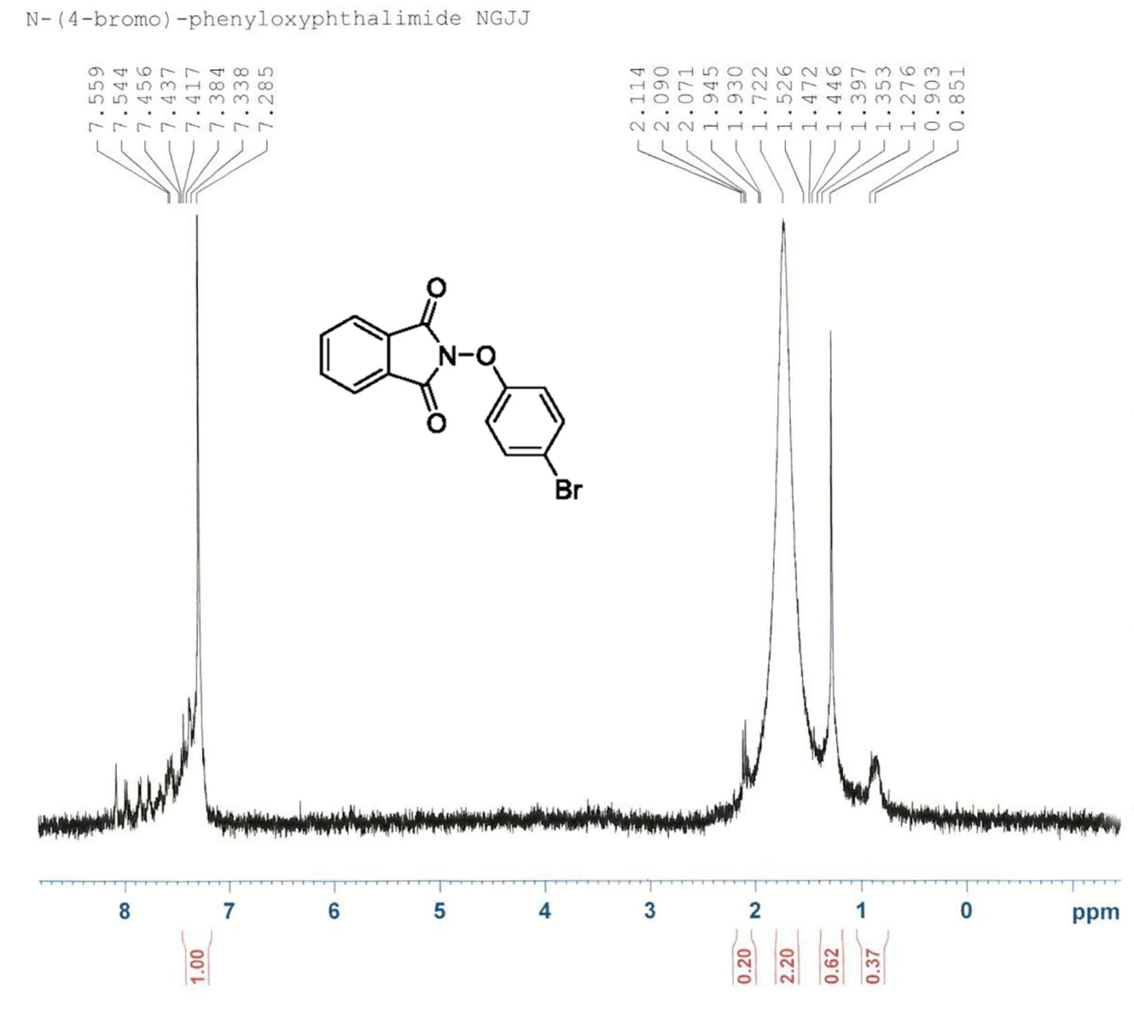
Figure 11 NMR showing the unsuccessful attempt to synthesize the product after step 2.

Although it was possible that the product sought after was present in the NMR it was clear that there were too many impurities in the compound necessitating another attempt. When executing the procedures the second time greater care was taken with measurements and temperatures and the first reaction took place immediately after the second. This H-NMR was supersaturated in hopes of amplifying the peaks that we sought after. Rather than dissolving a few crystals in chloroform-d, the chloroform-d was added directly to the solution. The H-NMR appeared much cleaner this time and is shown below.
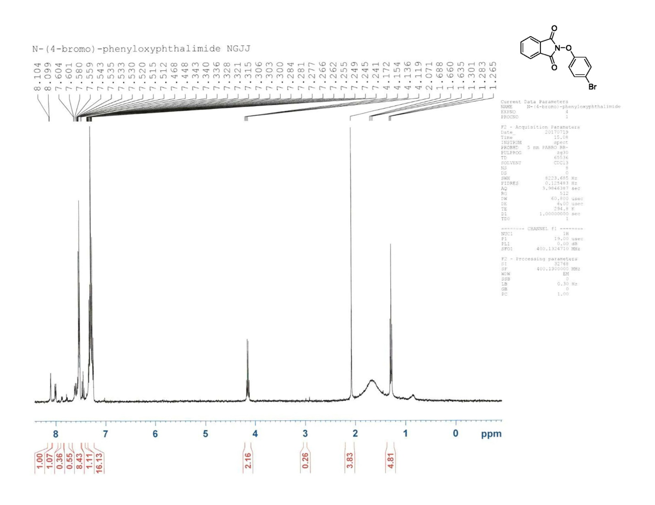
Figure 12. Shows the successful attempt to synthesize the product after step 2 once changes were made in the procedure.
The peaks between 7.4 and 6.8 are the peaks that resemble the N-phenyloxyphthalimide that was sought after step 2. Although the peaks are present, it is clear that there are many other impurities in the compound. In addition supersaturating the H-NMR sample did not have the amplifying effect that was expected as is clearly shown.
The compound was measured for mass and yield after the H-NMR. Since the chloroform-d was added directly to the compound, the compound was rotary evaporated to remove the chloroform. At this point the product we weighed at 0.346 mg and a 237% yield was calculated. Clearly this was incorrect so the compound was further inspected and it was discovered that the chloroform had not fully evaporator and the compound was rotatory evaporated once more. A second calculation revealed that the mass was actually 110mg and the percent yield was 75%.
Another change was made during the second attempt of synthesizing N-phenyloxyphthalimide. During the first attempted it was noted that in step 2, upon adding brine to the solution to improve the separation, the solution turned cloudy and white indicating a precipitate had formed. Regardless a separation still occurred with a clear aqueous layer and cloud white organic layer. After the cloudy white layer was dried using anhydrous sodium sulfate, the solution was gravity filtered and whatever white solid had formed was removed. On the second attempt it was suspected that there could be some of the sought after product in this solid. Instead of filtering it out with the anhydrous sodium sulfate, a gravity filtration was performed first to remove the white solid. An IR scan was then performed of this solid to help quickly identify its importance. The scan is shown below.
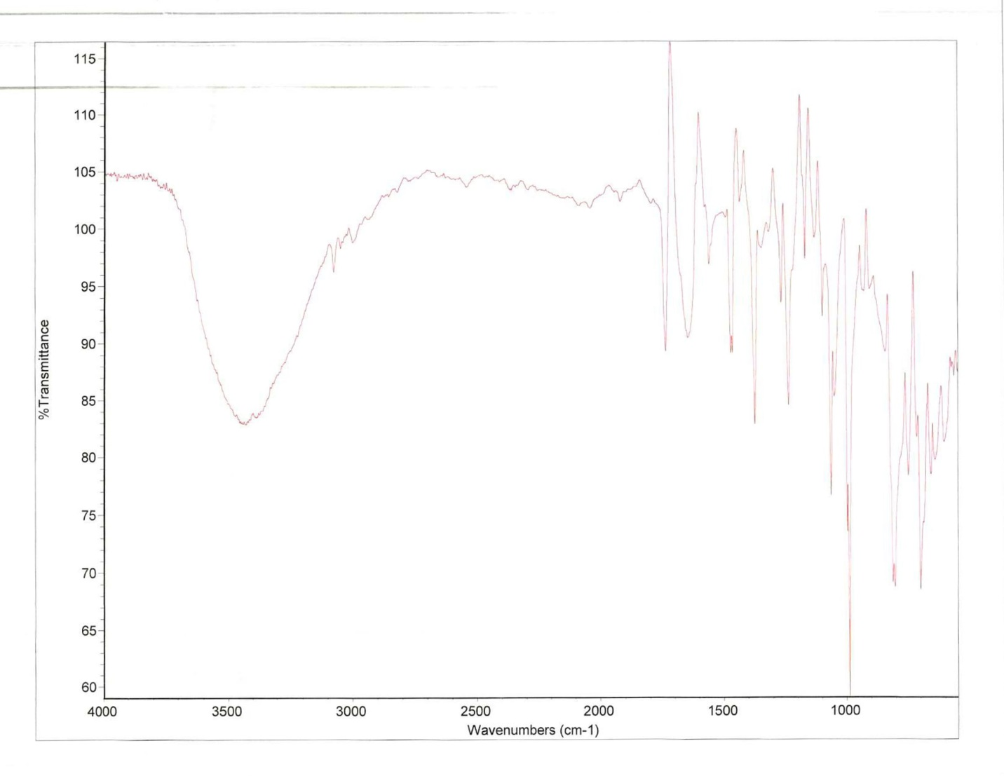
The scan shows that the transmittance between 1700 and 3250 % are very low; it is in these region that we would find any aromatic, benzene rings, in our compound proving that the white substance could be disposed of. The procedures were continued as outlined from this point out.
Method III outlined by DeSelm will be executed for further research in attempt to successfully synthesize the novel anti-tumor drug. According to DeSelm method II that was outlined proved to be unsuccessful after several attempts and H-NMR scans.
In the future, assuming that the compound is successfully synthesized, O-(4-bromo)-phenyl-N-(9’-acridinyl)-hydroxylamine will have to go through many tests and trials. Further design will have to be developed to concentrate and purify the product. DNA binding analysis will be completed as done by Carlson in her research to identify the effects of the Bromine substituent group. In addition other derivatives with different effects on DNA, such as O-(4-methyl)-phenyl-N-(9’-acridinyl)-hydroxylamines, will be produced. After the products is thoroughly synthesized, purified, and analyzed it will go into testing before reaching the market.

Acknowledgements
I would like to thank Matthew DeSelm for his experience with anti-tumor and anti-cancer drugs and for being both my mentor and advisor in writing this paper and carrying out my research. In addition, I am appreciative of the lab and calculation assistance provided by Saba Wolde. This project would not have been possible without the financial research contributions made by Xcel Energy to my participation in intimate research. Also acknowledged is Lori Ball, the director of the FSI program and the entire FSI staff, for providing us with this opportunity and Timothy Fredrick, Dr. Kevin and Monna Lear, and the Joseph Family for sponsoring our participation in this program. I would also like to thank my peers and my family for their continuous support through this wonderful program.

References
Bielawski, M., Zhu, M., & Olofsson, B. (2007). Efficient and General One-Pot Synthesis of
Diaryliodonium Triflates: Optimization, Scope and Limitations. Advanced Synthesis &
Catalysis,349(17-18), 2610-2618. doi:10.1002/adsc.200700373
Cancer Statistics. (2016). Retrieved July 25, 2017, from https://www.cancer.gov/about-
cancer/understanding/statistics
Carlson, A. O-benzyl-N-(9’-acridinyl)-hydroxylamines as Potential Antitumor Agents. Master of Science Thesis, University of Northern Colorado, Greeley, CO, 2015.
Danko, P., Kozák, A., Podhradský, D., & Víglaský, V. (2005). Analysis of DNA intercalating drugs by TGGE. Journal of Biochemical and Biophysical Methods,65(2-3), 89-95. doi:10.1016/j.jbbm.2005.10.00
DeSelm, Matthew. Design, Synthesis, and Biological Activity of O-phenyl-N-(9’-acridinyl)-hydroxylamines. Thesis. University of Northern Colorado, 2017. N.p.: n.p., n.d. Print.
Ghosh, R., & Olofsson, B. (2014). ChemInform Abstract: Metal-Free Synthesis of N-Aryloxyimides and Aryloxyamines. ChemInform,45(35). doi:10.1002/chin.201435073
Goodell, J. R., Svensson, B., & Ferguson, D. M. (2006). Spectrophotometric Determination and
Computational Evaluation of the Rates of Hydrolysis of 9-Amino-Substituted Acridines. Journal of Chemical Information and Modeling,46(2), 876-883. doi:10.1021/ci050322s
Gálvez-Peralta, M., Hackbarth, J. S., Flatten, K. S., Kaufmann, S. H., Hiasa, H., Xing, C., & Ferguson, D. M. (2009). On the role of topoisomerase I in mediating the cytotoxicity of 9-aminoacridine-based anticancer agents. Bioorganic & Medicinal Chemistry Letters,19(15), 4459-4462. doi:10.1016/j.bmcl.2009.05.037
Kerr, J. F., Winterford, C. M., & Harmon, B. V. (1994). Apoptosis. Its significance in cancer and
Cancer Therapy. Cancer,73(8), 2013-2026. doi:10.1002/1097-0142(19940415)73:8<2013::aid-cncr2820730802>3.0.co;2-j
Kumar, P., Kumar, R., & Prasad, D. N. (2013). Synthesis and anticancer study of 9-aminoacridine derivatives. Arabian Journal of Chemistry,6(1), 79-85. doi:10.1016/j.arabjc.2012.04.039
Samarasinghe, B. (2013, October 2). Hallmarks of Cancer 3: Evading Apoptosis. Retrieved July 25, 2017, from https://blogs.scientificamerican.com/guest-blog/hallmarks-of-cancer-3-evading-apoptosis/
Stacking Interactions and DNA Intercalation
Shen Li, Valentino R. Cooper, T. Thonhauser, Bengt I. Lundqvist, and David C. Langreth
The Journal of Physical Chemistry B 2009 113 (32), 11166-11172
DOI: 10.1021/jp905765c
Types of Cancer Treatment. (2016). Retrieved July 25, 2017, from https://www.cancer.gov/about-cancer/treatment/types
What Is Cancer? (n.d.). Retrieved July 25, 2017, from https://www.cancer.gov/about-cancer/understanding/what-is-cancer

